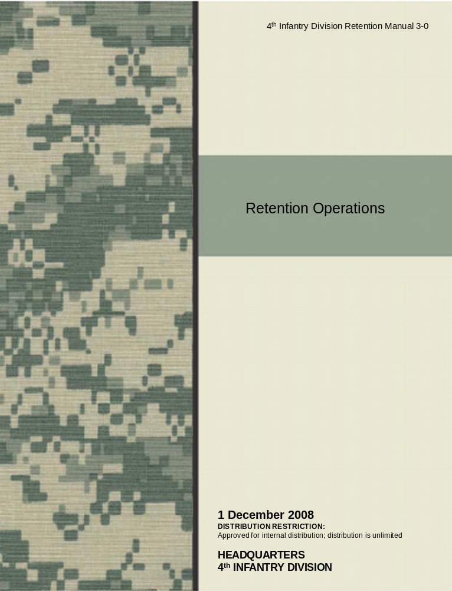
4th Infantry Division Retention Manual 3-0
1 December 2008

By Order of the Commander

Major General, USA
Commanding

Official

COL, GS
Chief of Staff

DISTRIBUTION: Distribution of this manual is in accordance with 4ID, distribution A. This publication is available at Army Knowledge Online (AKO) (4ID DIV REUP Internal Collaboration Folder-AKO).
RM 3-0

Retention Operations

Headquarters
No. 3-0 4th Infantry Division (M)
Fort Hood, Texas, 1 December 2008

RETENTION OPERATIONS

Contents

Page

Chapter 1 STANDARDS 6
Chapter 2 Setup a Retention Program 8
Chapter 3 SUSTAIN a Retention Program 11
Chapter 4 MANAGE a Retention Program 14

Appendix A Office Etiquette and Standards of ConducT 17
Appendix B Counseling 18
Appendix C MANAGE A RETENTION PROGRAM budget 20
Appendix D Retention Issue Paper 23
Appendix E Retention Contingency Operations 24
Appendix F Requests to Become a Career Counselor 28
Appendix G Mission process and Management 31
Appendix H Career Counselor Development and Promotions 34
Appendix I Training 40
Appendix J BRIEFINGS 41
Appendix K STRATEGY 42

GLOSSARY 44
REFERENCES 45

This publication is available at
Army Knowledge Online (AKO) (4ID DIV REUP Internal Collaboration Folder-AKO)

Preface

The Retention Operations Manual 3-0 is the first edition of its kind. This manual takes into account aspects from various publications, which depict information not otherwise taught to retention personnel and applies that information and lessons learned culminating in tactical and operational principles for retention programs in the division.

Purpose

This manual provides standards for retention personnel and emphasizes the fundamentals required to perform retention duties in support of the Total Army Retention Program in the gamut of military operations.

Scope

Retention Manual (RM) 3-0 is a user manual for retention doctrine at the company level to division level. It emphasizes experience concepts and provides best practices.

Applicability

The principle audience for this manual is the career counselor and retention NCO. However, Commanders, Command Sergeants Major, First Sergeants, and leaders can benefit from the information contained herein.

Introduction

AR 600-100 states that, “The Army’s strategic objectives clearly state the Army’s purpose: …sustain an all-volunteer force composed of highly competent Soldiers….” What one does to accomplish the Army’s strategic objectives depends on one’s actions. Everything we do revolve around the mission: planning, preparing, executing and completing the mission. There are no alternatives.

The foundation of a retention program consists of four phases—developing standards, setting-up, sustaining, and managing. Developing expectations is the leading step in establishing a successful program followed by developing an action plan.

Setting up a retention program is more than merely establishing an office. More so, it entails developing a retention plan to accomplish the retention missions.

Sustaining a program begins with assessing the plan that was developed in the setup phase. It also includes conducting staff assistance visits, site visits, and evaluation of retention personnel. Continuous assessment of the retention plan is foremost in identifying inhibiting factors effecting accomplishment of the retention mission.

Management of a retention program is the most important element of a retention program. Establishing standards, setting up and sustaining a retention program are the basics of establishing a retention program; management of the program determines its outcome.

Proponent

The proponent for this manual is Headquarters, 4th infantry Division, ATTN: Division Reenlistment. Send comments and suggested improvements to Headquarters, 4th infantry Division, ATTN: Division Reenlistment, Room 106A, Fort Hood, TX 76544.

Unless otherwise stated, whenever retention personnel is used, both Career Counselors and Retention NCO’s are intended. Additionally, unless stated otherwise, masculine nouns or pronouns do not refer exclusively to male Soldiers.
Chapter 1

Responsibility, Standards and Discipline

“Commanders are responsible for everything their command does
or fails to do. However, commanders subdivide responsibility
and authority and assign portions of both to… staff members.
In this way, a proper degree of responsibility becomes inherent….”
~AR 600-20

The opening statement to this chapter concludes with, “Commanders delegate sufficient authority to Soldiers… to accomplish their assigned duties, and commanders may hold these Soldiers responsible for their actions.” The question then becomes, what is the difference between responsibility and accountability?

Accountability
In regards to this manual, the Wikipedia definition for accountability is, “In leadership roles, accountability is the acknowledgment and assumption of responsibility for actions, products, decisions, and policies including the administration, governance and implementation within the scope of the role or employment position and encompassing the obligation to report, explain and be answerable for resulting consequences.” Wikipedia goes on to define responsibility as, “People are causally responsible for events when those events are directly brought about by their actions. Often when people have moral responsibility for a situation, they also have causal responsibility for that situation. Someone who is praised for acting in a morally responsible way has usually caused some good state of affairs to occur.”

Responsibility
The commander delegates authority to retention personnel to fulfill their assigned duties and responsibilities as career counselors and retention NCOs. As professionals, retention personnel inherit a degree of responsibility to accomplish the retention mission. Too often, especially when failing or struggling to accomplish the mission retention personnel dodge their inherent responsibility with a claim that the mission is solely the commanders. It is at such times that retention personnel must take a moment and reflect upon the inherent duties as an NCO and the Army Values.

FM 7-22.7, infers that duty means to “Fulfill your obligations.” It goes on to read, “Take responsibility and do what's right, no matter how tough it is, even when no one is watching. Accomplish all assigned or implied tasks to the fullest of your ability.” By not serving to the utmost of one’s retention duties, one forsakes their duties and fellow career counselors to include the commander.

The Career Counselor Creed and NCO Creed conclude with, “My superiors will not be burdened with my duties and responsibilities…” and “Officers of my unit will have maximum time to accomplish their duties, they will not have to accomplish mine…” respectively. Retention personnel must have the conviction and moral courage to stand up, accept liability for their actions and assume responsibility to accomplish the mission.
Responsibility also means executing Soldier, NCO, and retention duties in a professional, reliable, and trustworthy manner where accountability translates into adhering to regulatory and legal requirements and facing the consequences when one fails to do the responsible things. Accordingly, accountability begins by enforcing standards and expectations. Brandon O’Dell, business owner and consultant stated, “Accountability has to be taught as an expectation.” Once the expectation is taught, it becomes the standard; enforce it.

Standards
It is incumbent upon retention personnel to represent their unit and the United States Army in a steadfast and professional manner. The standards for division retention personnel are:
- Accomplish the Mission
- Fulfill the Duties and Responsibilities of a Career Counselor, Retention NCO, and NCO
- Be a Leader; Be Professional; Live the Army Values
- Maintain Competency, Confidence, and Take Responsibility
- Communicate-Keep the Commander, CSM, and the Command Career Counselor (Retention SGM) Informed; Listen
- Provide Unequivocal Counsel to Leaders, Soldiers, and Families
- Plan, Prepare, Execute, and Assess
- Anticipate, Shape, and Influence
- Be Prepared
- Never Quit
- Train
- Assign senior career counselor to the BCT or BDE; all other counselors will be assigned to a subordinate battalion; no consolidated retention offices
- Command teams will evaluate-rate-their assigned career counselor or retention NCO

Discipline
Retention personnel must be disciplined and must have the strength to overcome adversity. Retention personnel must remember that they are NCO’s-Leaders. Leaders that:
- Have the Conviction to Enforce the Standards
- Lead from the Front
- Possess Moral Character
- Hold Subordinates Accountable and meet the Standards Themselves

Relief of Retention Personnel
Retention personnel that fail to meet the standards set forth in this manual, AR 601-280 and other pertinent policies and or regulations is subject to removal from retention duties and possible relief and reclassification.

Chapter 2

Setup a Retention Program

A successful retention program relies more than just receiving a mission and trying to accomplish that mission. Just as in FM 3-0, it requires planning, preparing, executing, and assessing. Retention personnel must be cognizant of the non-lethal effects of not setting up a retention program properly. By not having or supplying the resources required to perform ones functional responsibilities, the effect is that it could contribute and result in failing to accomplish the mission.

Setting up a retention program requires having resources and guiding principles.

Section I - Resources
Resourcing entails obtaining or establishing:
- Office space
- Publications and forms. All necessary forms and publications necessary to perform retention responsibilities are available at the United States Army Publishing Directorate website, Army Publishing Directorate
- A means of communications that include but are not limited to ILAN and a telephone.
- Hardware, software and support. I.e. laptop computer, printer, scanning and faxing capabilities
- An eMilpo, RETAIN, EDAS, and ATRRS accounts
- A budget (See Appendix C)
- The staff needed to perform the tasks required to accomplish the retention mission (Appendix H describes career counselor authorizations; where no career counselor authorization exists, AR 601-280 provides information on appointment of a retention NCO. Full-time or additional duty appointment memorandums are available for download at 4ID DIV REUP Internal Collaboration Folder-Retention NCO Appointment Memorandum)
- An administrative person to perform administrative functions required as part of everyday retention operations

Section II-Guiding Principles
Guiding principles begin with the development of administrative functions, which include:
- Establishment of policies and standards for the office (See Appendix A)
- Development of standard operating procedures
- Implementation of an awards program
- Implementation of a reenlistment incentive policy
- Development of program and guidebooks (Figure 1.3 illustrates a sample retention program book and Figure 1.4 illustrates a sample retention person’s book)
- Development of briefings (See Appendix J)
- Development of a strategy (See Appendix K)


- Appointment Order
- Incentive/Awards Policies
- Previous FY Statistics
- Current FY Statistics
- Previous FY Eligible’s Roster
- Current FY Eligible’s roster
- Bars to Reenlistment
- Tracking Sheet
- Certificate
- DCSS
- Tracking Sheet
- Statement
- Mission Memorandum previous FY
- Mission memorandum current FY
- RETAIN Messages/Bonus/IN/OUT Call
- DA Form 4591-1-R
- DA Form 4591-2-R
- DA Form 4591-R on SSG and below not indef
- Previous FY SAVs
- Current FY SAVs
- AR 601-280 w/Changes
Figure 1.3. Sample Retention Program Book


A retention person’s reference guide is not limited to, but should include:
- AR 601-280 with changes
- SRB Message
- Bear Message
- IN/OUT Calls Message
- Reenlistment Option Information
- Reclassification Information
- Information Regarding Career Opportunities for Soldiers
- RC to AC Information
- Job-Aids
- Counseling/Interview Aids
- Reference Sheet to publications and websites useful to Soldiers and Self
- Benefits Sheet
- Retention Program and News/Media Talking Points
Figure 1.4. Sample Retention Personnel Reference Guide

Section III-Taking over a Program
When taking over a program, there are important things that need to be done, such as:
- Introduce oneself to the command’s leadership
- Assess/Analyze:
  - Historical Data: Statistics, Training, Surveys, and SAV’s
  - Trends-How many Soldiers are reenlisting to stay with the unit conversely, how many are reenlisting to leave the unit. What units have and are doing well and not well
  - Retention Personnel Performance-Are they coming to work? Are they executing their duties and responsibilities? Organizational Skills? Do they constantly have excuses for everything? Do they have a reputation of failing to accomplish the mission? Are they engaged in training? Are they communicating to the leadership? What communication formats are they using?
  - Mission Issuance to Company Level-Is the mission being issued to company level?
  - Command Involvement
  - Resources: Equipment, Personnel, Automation, and Funding-Do retention personnel have the required resources needed to accomplish the mission.
  - Administrative Office Files-Is there an administrative file? Are guiding principles present, being adhered and enforced?
  - Capabilities: Automation Operational Knowledge-Do retention personnel know how to use Microsoft applications, RETAIN, iPERMS, etc?
  - Publicity Campaign [Advertisement]-Is there a publicity campaign?
- Conduct Initial SAV
- Identify and Review Issues

Retention personnel must be cautious and not be too quick to make change when they arrive. One must take their time to assess and thoroughly analyze the information they found during their assessment.

Chapter 3

Sustain a Retention Program

Once the program is setup, it is essential to keep it functioning. Continuous assessment of the retention plan is foremost in identifying inhibiting factors effecting accomplishment of the retention mission. Having an established system of checks and balances also results in retention personnel performing to standard.

Assessment
The primary documented method to identify potential shortfalls, in a program, is through assessment. AR 601-280 and FORSCOM Retention MOI direct program assessment via conducting Staff Assistance Visits (SAV). In addition to SAVs, assessment should include evaluating the retention strategy, effectiveness of the publicity campaign, and by conducting AARs. Furthermore, assessing the relevance and state of the retention force is just as prudent.

Evaluation, relief, and or replacement of career counselors and retention NCO’s is an integral part of sustaining a retention program and maintaining a ready and relevant counselor force required to conduct retention operations. Senior career counselors must continuously monitor the quality of NCO’s serving in retention positions. The Command Career Counselor is responsible for ensuring that the division has a ready and relevant retention force. Additionally, the Command Career Counselor is responsible for training and utilization of the the retention force and ensuring the force is tactically, technically, and physically ready and capable to deploy.

Career counselors and or retention NCOs need to ensure they plan, prepare, execute, and assess their respective retention strategies. Senior career counselors need to ensure that their retention personnel conduct training: MOS proficiency, Warrior Tasks, NCOPD, OPD, MRT, and quarterly retention training. Appendix I provides information regarding tracking of training.

Performing functional tasks to standard ensures that retention personnel focus in a forward direction. The 79S_STP manual depicts the tasks career counselors perform as part of their day-to-day operations. In addition to the tasks listed in the 79S_STP manual, there are various other tasks critical to sustaining a program; Table 2.1 below depicts these tasks.

Retention Tasks:
Conduct Resupply Operations
Maintain Forms and Publications
Conduct a Retention Awards Ceremony
Develop a Unit Reenlistment Incentive Policy
Develop a Unit Reenlistment SOP
Write a Reenlistment Mission Memorandum
Develop and Maintain a Planning Guide
Write a Fact or Information Paper
Write a Retention Executive Summary (EXSUM)
Conduct a Sustainment Counseling
Conduct an Interview (Interviewer/Interviewee)
Conduct RIP/TOA
Develop a Mission Action Plan
Establish Retention Measure of Effectiveness (Glide Path)
Conduct an AAR
Establish Retention Communications
Conduct Redeployment Operations
Conduct a Survey
Recommend an NCO to Reclassify to 79S
Conduct a Retention Publicity Campaign
Supervisory Tasks:
All Preceding Tasks
Conduct Retention Operations NCO Operations
Write and Evaluate an NCOER
Evaluate NCOER Submissions
Write and Evaluate an Award
Evaluate a Recommendation to Reclassify into a 79S
Write a Mission/Problem Statement
Write a Retention Issue paper
Conduct Sponsorship and Integration Operations
Manage 79S Force (See Appendix H)
Manage DJMS Report
Manage CMS Submissions
Manage 79S Leaves
Manage SGM COMP Report
Assess a Retention Program
Manage Retention Transfer of Responsibility Operations
Manage Executive Correspondence
Manage Retention Bench Marks
Manage Rear Detachment Transition Operations
Manage Rear Detachment Retention Operations
Supervise AAR Operations
Manage Retention Redeployment Operations
Manage Execution of Surveys
Manage Recommendations of an NCO to Reclassify to 79S
Manage RETAIN Users
Reset RETAIN Password
Manage RETAIN HOTLINES
Manage Soldiers on Assignment Instructions
Manage Loading Soldiers in RETAIN (Reenlistment, Extension, and Reclassification)
Manage RETAIN Worksheets (Reenlistments/Extensions/Reclassification)
Manage Pending Reenlistment, Extension, and Reclassification Actions
Manage Reenlistment Program Budget, Publicity Item Acquisition, and Distribution
Evaluate and Supervise Retention Training/Seminar/Conference
Evaluate and Supervise MOS Proficiency and Soldier Skill Training
Evaluate a Retention Mission Plan
Conduct a Career Counselor of the Year Board
Conduct Rear Detachment Retention Operations
Manage VAL/RENO Contracts
Table 2.1. Sustaining Tasks.

Chapter 4

Manage a Retention Program

Setting up and sustaining a retention program are the basics of establishing a retention program; how one manages a program will determine its outcome. Managing a retention program entails more than performing a quality control check of retention packets. Effectively managing the day-to-day operations, functions, and staff will confidently culminate in successful accomplishment of the mission.

Team Building
Team building is essential to any organization. Building a team alone in itself does not ensure accomplishment of the mission. However, bringing the team together to work as one sharing a common purpose greatly enhances the team’s ability to accomplish the mission. Building a team requires finding the right people for the job, providing the team clear guidance, and inspiring them to achieve to succeed.

The first step in team building begins with staffing. However, staffing is more than getting people for the job; it is putting the right people in the right place of the job. Once you build the team, the next step is to instill to the team their purpose. The Career Counselor Creed is a means of reference that one can use to provide a purpose. Once the team knows why they are there, provide clear guidance-direction-to accomplish the mission. Specificity is the operative word in this phase of team building.

The last step in building a successful team is to inspire the team. Key elements to motivation are to reward and recognize individual and team efforts. An example of motivating a team includes but is not limited to an event such as; “who is the man,” “king of the hill,” and “top dog.” For example, in “who is the man,” the counselor that leads the command in accomplishments is identified as “the man.” Every time that an individual enters the room, he asks, “Who is the man?” Everyone responds with, “You the Man.”

Having an awards program is another useful tool that counselors can use to reward and recognize individual and team efforts. This competitiveness promotes a desire to win because no one wants to be a loser. Teambuilding is more than promoting a competitive spirit it includes attending social functions and events with the unit as well. This will help build creditability with the unit.
Establishing Creditability
Retention personnel are the commands subject matter experts. The following traits will help build a retention person’s creditability:
- Accomplishing the mission
- Displaying Professionalism
- Living the Army Values
- Being Competent
- Being truthful and trustworthy
- Communicating with the command team
- Showing up for work
- Displaying dedication and commitment
- Perhaps the most profound thing that will establish a career counselors or retention NCOs creditability is understanding that they are Soldiers first
- Being a Team player

Evaluating Career Counselors
Senior career counselors, commanders, and CSM’s must continuously evaluate the very force that retains the force commanders need to fight the battles of tomorrow. Evaluation consists of two parts: evaluating a career counselor or retention NCO’s competency and professional development.

Career counselors that do not live up to the professional, ethical and moral standards expected of career counselors should be considered for removal from retention duties. This includes NCOs serving in retention NCO capacities as full-time retention NCOs or those serving at the tactical level as additional duty retention NCOs. Detailed information regarding reclassification and or relief of career counselors can be found in AR 601-280.

Senior career counselors need to ensure that they know how to evaluate and rate career counselors properly. This includes advising commanders and CSMs accordingly. The senior career counselor should also advise commanders and CSMs on evaluating and rating of BN retention NCOs. Appendix H provides detailed guidance on professional development and promotion of career counselors.

Sponsorship and Integration
An overlooked area in the retention arena is sponsoring and integrating a fellow career counselor into the unit. It is important that we take care of our own and that starts by:
- Identifying who is inbound
- Sending a welcome letter
- Appointing a sponsor
- Sponsor contact
- Sponsor providing assistance
- Unit introduction
- Unit integration

Coping with Stress
Retention is a demanding and rewarding job that at times can become stressful. Maintaining faith and motivation can become arduous tasks. Geographically speaking, it does not matter your location; stress has no boundaries. Stress can engulf one in a tactical as well as non-tactical environment. Stress amplifies when one is in a combat environment and as leaders; we must be vigilant at all times. CALL handbooks, the First 100 Days, Commander and Staff and Leader’s Handbook, provide insightful information to help deal with stress. It is incumbent upon senior career counselors to know how to identify it stress, cope with, and seek help when necessary.

Staying Motivated
Staying motivated is essential to ensure accomplishment of the mission and welfare of Soldiers and self. Finding methods to relax will help keep one motivated. Methods to help one stay motivated include but are not limited to:

- Spending quality time with friends and family
- Go to a movie
- Reading a book
- Participating in a group sport activity
- Physical, mental, and spiritual fitness activities
- Talk to a trust worthy person
- Participate in team-building activities
- Enforce standards and discipline

Hosting an Event with a Guest Speaker
Retention personnel at all levels will host an event such as an awards ceremony, training or briefing where a senior officer or NCO is invited to be a guest speaker. Retention personnel need to ensure they follow protocol to give that officer or NCO their due respect. Things to consider are:
- Obtain the guest speaker’s biography
- Coordinate for transportation
- Coordinate for sponsorship/escort
- Provide agenda/general brief
- Coordinate meet and greet with the units command team
- Coordinate for billeting
- Coordinate for sustenance
- Coordinate force protection
- Provide seating
- Provide refreshments
- Introduce the guest speaker
- Thank the speaker when they are done
- Provide the guest speaker with a token of your appreciation-gift

Appendix A
Office Etiquette and Standards of Conduct

The retention office is ones place of duty not a place of recreation. Although visitors are welcome, retention personnel must limit their stay unless they are there for business purposes. Office personnel need to take into consideration that their visitors can be a distraction to other personnel in the office.

The playing of music in the office is ok; but the music should be in good taste and not detract the professional solemnity of the office and its occupants. The volume should not interfere with the workflow and business/telephone conversations.

All Soldiers’ are required to abide by the standards of conduct contained in AR 600-50. In addition to those standards, retention personnel should present an outstanding attitude and appearance at all times. Their position is one in which they are observed by potential reenlistees, both on and off duty. It is essential that retention personnel present an attitude and appearance that will reflect the highest level of honor upon them and the unit.

Reenlistment personnel need to be professional at all times and should refrain from using fowl language while in the office. Reenlistment personnel need to also comply with AR 600-20 regarding speaking any language other than English. Being professional includes speaking properly--avoiding slang and jargon. The use of such language is not conducive to the profession of counseling and does not conform to the standards set forth in DA Pam 611-1. Lastly, reenlistment personnel need to be respectful and professional when speaking to anyone on the phone.

Retention personnel will spend time away from the office to perform and accomplish retention activities. As a matter of courtesy to personnel who visit the office, retention personnel need to develop a system to indicate when one will return. A sample door chart is located Figure A.1.

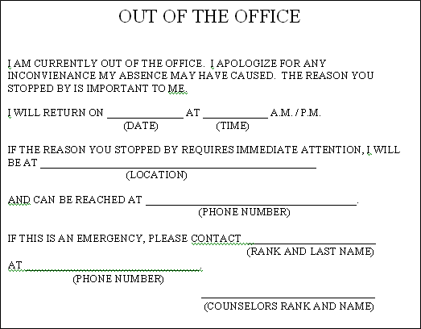
Figure A.1. Sample out of office door sign
Appendix B

Counseling

“In order to sell a product effectively, a salesman must believe in the utility and superior merits of his goods. With reference to the Army, this implies more than passive patriotism or the acceptance of it as a necessary service.”
~DA PAM 611-1

The Science of Counseling
Webster’s New World Dictionary defines counseling as 1) to give advice to and 2) to recommend (an action, etc.). Additionally, the dictionary defines a counselor as an advisor. Therefore, a Career Counselor or Retention NCO advises and gives recommendations to. However, a Career Counselor and Retention NCO’s responsibility includes conscription. Hence, a Career Counselor and Retention NCO provide counsel and recruit Soldiers to reenlist. The result from a counseling session is to affect a response from Soldiers to make a decision to continue serving in the Army. Getting that result entails more than just counseling a Soldier. There is a science and art to counseling.

The science of counseling deals with knowledge, techniques, and strategies. The Basic Career Counselor Course provides instruction on techniques and strategies when conducting a counseling session and presentation. These techniques and strategies along with substance from publications such as, AR 601-280, The Army Career Counseling System, located at Appendix C, FM 6-22, Army Leadership, Appendix B, and DA Pam 611-1, The Army Interview, can increase ones knowledge base ultimately enhancing their aptitude when counseling Soldiers.

Since retention personnel are in the business of selling by getting Soldiers to reenlist, perhaps the biggest pitfall they have is selling. Since institutional training does not teach in-depth sales training, retention personnel have to increase their individual knowledge base and educate themselves. Techniques such as Consultative Selling, Value Added Selling, Qualifying Sales, Sales Persuasion, Solution Selling, Guided Selling, Cold Calling, Warm Calling, and Door-to-Door are all type of techniques that can help.

The Art of Counseling
The art of counseling is the application of the scientific knowledge. Possibly, the best method to the art of counseling is to avoid common mistakes. Common mistakes include a poor attitude, being unprofessional, loss of creditability, appearing argumentative, not being prepared, inability to overcome objections, lack of knowledge, poor techniques, not listening, targeting the wrong market and or person, and not having a follow-up practice.

The primary job of a Career Counselor and or Retention NCO in getting a Soldier to reenlist is to influence a Soldier to want to stay in the Army. Applying the science and art of counseling can assist in achieving that endeavor.

Transition Counseling
Not every Soldier will reenlist. When a Soldier makes the decision to separate, they will tell an Army story. The Army story they tell is usually based on their treatment as they transition out of the Army. It is crucial that retention personnel provide full circle counsel to all Soldiers regardless of their intent to stay or separate. One does not need to get upset because they did not get the sale, rather one needs to assist the Soldier with their transition; showing Soldiers that we-as an institution-care will result in a positive story. The benefit is that by providing total care for Soldiers it will result in positive future strategic implications.

Appendix C
Manage a Retention Program Budget

Develop
The first step to developing a budget is to identify needed requirements. These include training, awards, office supplies, automation upgrades, RPI’s, publicity, and TDY for SAV’s, site-visits, and conferences, etc. Once identification is complete, the next step is to prepare an estimate for each requirement.

Estimate
Estimating the dollar amount for the identified requirements may require research and analysis. When determining the estimate costs do not forget to take into account the priority for the requirement, date funds are required, the number of personnel, and number of items. Refer to the matrix in figure C.1 to use as a guide. Additionally, determine an expenditure time-line. See Figure C.2.

ORG | Retention
Priority | Requirement | Purpose | Count | Funding Method | Est Date | Freq | Est Cost | Cum Cost
1 | TDY | HQDA RSSG | 2 |  |  | Ann | 2.5K | 5K
2 | TDY | WWRTS | 10 |  |  | Ann | 2.1K | 21.1K
3 | TDY | FC Workshop | 2 |  |  | SA | 2.5K | 5K
4 | TDY | MRT | 2 |  |  | Ann | 1.8K | 3.6K
5 | TDY | HRC | 1 |  |  | SA | 3.3K | 6.6K
6 | TDY | CCOYB | 3 |  |  | Ann | 1.8K | 5.4K
1 | Training | Seminar | 40 |  |  | SA | $200 | 16K
1 | Training | Guest Speaker | 1 |  |  | SA | 3K | 6K
1 | Supplies | Supplies | Var | GPC |  | Mo | 10K | 10K
2 | Supplies | Printing | Var |  |  | Qtr | 2K | 8K
3 | Awards  RPI | Copier | 1 |  |  | Mo | $240 | 2.8K
4 | Awards  RPI | Automation Upgrade | 8 | Contract |  | Ann | 2K | 16K
1 | Awards  RPI | Recognition | 31 | GPC |  | Qtr | $25 | 3.1K
2 | Awards  RPI | Promotional | 2800* | Contract / GPC |  |  | $50 | 140K
1 | Publicity | Advertisement |  | GPC |  | Qtr | 2.5K | 10K
Figure C.1. Estimated budget requirements *# of Eligible Soldiers

 | Oct | Nov | Dec | Jan | Feb | Mar | Apr | May | Jun | Jul | Aug | Sep | Total
 | 1st Quarter |  |  | 2nd Quarter |  |  | 3rd Quarter |  |  | 4th Quarter
TDY | 21.1K |  |  |  |  | 7K |  | 6K
Training |  |  |  |  |  | 7.5K |  |  |  |  |  | 7.5K
Supplies | .9K | .9K | .9K | .9K | .9K | .9K | .9K | .9K | .9K | .9K | .9K | .9K
Printing |  |  | 1K |  |  | 4K |  |  | 1K |  |  | 2K
Awards |  |  | 1.5K |  |  | 1.5K |  |  | 1.5K |  |  | 1.5K
Publicity | 5K |  |  |  |  |  | 5K
RPI | 5K | 5K | 5K | 5K | 5K | 5K | 5K | 5K | 5K | 5K | 5K | 5K
1BCT | 3K | 3K | 3K | 3K | 3K | 3K | 3K | 3K | 3K | 3K | 3K | 3K
2BCT | 3K | 3K | 3K | 3K | 3K | 3K | 3K | 3K | 3K | 3K | 3K | 3K
3BCT | 3K | 3K | 3K | 3K | 3K | 3K | 3K | 3K | 3K | 3K | 3K | 3K
4BCT | 3K | 3K | 3K | 3K | 3K | 3K | 3K | 3K | 3K | 3K | 3K | 3K
STB | 3K | 3K | 3K | 3K | 3K | 3K | 3K | 3K | 3K | 3K | 3K | 3K
RC | 3K | 3K | 3K | 3K | 3K | 3K | 3K | 3K | 3K | 3K | 3K | 3K
Totals
Figure C.2. Sample monthly budget estimated expenditure matrix

Next, submit the budget requirement to the responsible agency. A sample memorandum is available at 4ID DIV REUP Internal Collaboration Folder-Sample Budget Memorandum.

Documentation
Supporting documents to the budget memorandum must include the budget estimate and monthly estimated expenditure. Once all the required documents are in order, staff the budget request to the approving official.

Manage Retention Promotional Items
Retention promotional items should be purchased for advertising the retention program. Items of high value should not be procured. At a minimum the unit logo or title should appear in a prominent position on the item, along with a phrase advertising remaining with that specific unit or with one of the components of the Army. When requisitioning RPI’s, career counselors must ensure that the request contains multiple vendor quotes or if only one vendor quote, a sole source memorandum, and artwork for each item.

Procurement Methods
You can procure the products through Government Purchase Card (GPC), AQUILINE, and PR&C (DA Form 3953). Each procurement method has its own uniqueness in regards to processing and dollar amounts. The GPC method is the quickest but has its drawbacks: single purchase dollar limit and the potential to make a split-purchase violation; the alternative is to contract.

The contract process includes the PR&C and AQUILINE. The contracting process will eliminate the downside of the GPC. AQUILINE is an electronic, paperless method for developing, routing, funding, reviewing, and determining status of purchase requests forwarded to contracting.

Program Advertisement
Program promotion is an enduring effort aimed at sustaining the force by influencing Soldiers to reenlist. A publicity campaign consists of three-parts: information operations, advertisement, and partnership.

Information operations consist of publicizing bonus messages, incentive policies, and available career enhancing opportunity information on unit bulletin boards. Refer to Figure C.4 for a sample unit reenlistment bulletin board. With today’s technology, do not limit information to a bulletin board that exists in unit areas; create virtual information boards.

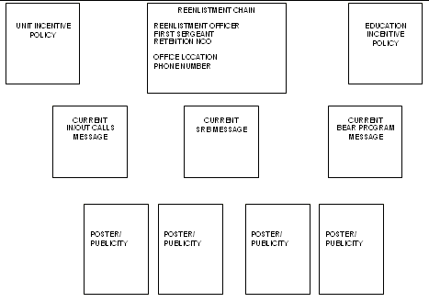
Figure C.4. Sample Unit Reenlistment Bulletin Board

Target Marketing
A publicity campaign entails advertising a program through the media and products. Advertisement means engaging support from available assets such as public affairs. Before engaging the PAO to publicize your program, consider what it is you are trying to achieve. Establish measures of performance and effectiveness to assess its outcome. Lastly, identify conduits that you can use such as newspaper, television, internet, radio, community events, DVIDS, and local organizations to advertise the program.

You are busier than ever, but you are not getting reenlistments. Things to consider when marketing:
- What are you trying to get out of your marketing
- Look at the message content of flyers, posters, etc.
- Identify the market
- Target promotions to decision makers
- Target with facts
- Gender
- Age

Product advertisement refers to Reenlistment Publicity Items (commonly referred to as RPIs). RPI acquisition is governed under Title 10 USC (2261) and AR 601-2. RPIs are products used to recognize personnel for retention purposes. One important thing to consider when developing RPIs is to consider product receiver. Generally, a 20-year old does not want a coffee cup; they want something geared toward their age group like an MP3 player. Conduct research to learn what products are functional, durable, cost effective, and beneficial to the Soldier receiving it.

Appendix D
Retention Issue Paper

With a transforming Army, the Army and retention operations are fluid. As a result, changes to tactics, techniques, and procedures become necessary. Therefore, retention personnel are highly encouraged to submit an issue paper (see Figure D.1 for a sample format). Submission of issue papers will follow the following hierarchy:
- Submitter to senior BCT/BCT career counselor to
- The Division Retention Office (DRO)
- The DRO to FORSCOM
- FORSCOM to HQDA
At no time will an issue paper be submitted to a higher HQ’s without the DRO’s consent.

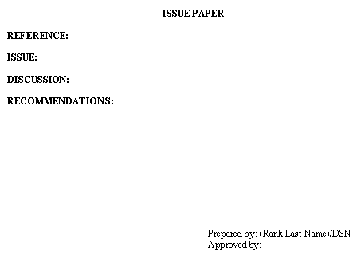
Figure D.1. Sample Issue Paper Format

Appendix E
Retention Contingency Operations

Regardless of deployment status, retention personnel need to have a plan that provides uninterrupted retention support to Soldiers throughout all phases of any operations. In addition to chapters 1-3 and Table 2.1 of this manual, AR 601-280, Appendix H, and FM 1-0, Appendix L, the below listed tables depict areas to consider during contingent operations. The basis of having such a plan is to anticipate, shape, and to influence the outcome. The contingent plan consists of three phases with multiple operations.

Purpose
The purpose of developing a contingent strategy is to provide and conduct continued uninterrupted retention operations during contingent operations with a focus on that results on accomplishment of the retention mission.

Concept of Operations
Contingency operations consist of three phases with multiple operations. The phases of a deployment consist of pre-deployment, during, and after. Upon initiation of contingency operations, the DRO activates a retention support cell and begins immediate brainstorming to ensure that all phases and operations listed in table E.1 get considered.

Prior to Deployment
Prior to deployment, the senior career counselor will provide a mission brief to all subordinate retention personnel that include critical information. Brief:
- The importance of having a plan for all phases of the mission
- Mission action plan
- Safeguarding and distribution of contracts
- Soldier SRB entitlement comparison (deployed vs. not deployed)
- Incentive and awards policies
- RPI Acquisition/Prepositioning/Storage/Distribution
- ARFORGEN and how it affects reenlistment options. Pay particular attention to critical points during ARFORGEN (4ID DIV REUP Collaboration Folder-ARFORGEN)* Retention personnel must see
- Brief retention personnel on how to set-up, sustain, and manage a retention program
- Brief retention personnel on the importance of obtaining connectivity to have access to email-AKO, EDAS, ATRRS, RETAIN, Emilpo, and iPERMS.
- Coordinate with the respective S/G 2 or 6 section to obtain access to the network.
- Activate rear-D operations cell
- Personal family plans
- Unit level retention NCOs on their responsibilities and roles while deployed
- Leave plan to ensure that not all counselors are on leave simultaneously. Rear-D leave plan. Counselor redeployment leave plan.
- Plan to deploy/redeploy counselor with:
  - ADVON
  - Main body
  - Trail party
  - To cover down operations at mid passage point; provide retention support to Soldiers at camp, SPOD and wash-rack details
  - At redeployment, ADVON to CONUS to take leave and set-up operations to receive unit allowing other counselors to reintegrate and take leave prior to main body arrival

PCC/PCI
The senior career counselor will conduct pre-combat checks and inspections. The senior career counselor will check:
- Individual Soldier equipment
- Contingency operations plan
- Mission action plan
- Incentive and awards policies
- That retention personnel prepare a retention packet consisting of a DA Form 4591-R (Retention Data Worksheet) and ERB for Soldiers (not serving on indefinite status) during the current fiscal year mission window plus 2-years
- That Soldiers are prepare in RETAIN (No screened record will be placed in a PEND status)
- Ensure that they deploy with sufficient automation hardware/software, blank forms, publications, office supplies and block reenlistment/extension control numbers (if applicable) to support retention operations. The following link, 4ID DIV REUP Collaboration Folder-Deployment Equipment Checklist, provides a checklist that retention personnel can download and use to ensure they have the necessary resources needed during the deployment
- RETAIN message file
- Deployment UK
- Personal family plans

Actions when retention personnel do not deploy (Rear-D Operations):
- Executes all functions and responsibilities depicted in AR 601-280 and this manual
- Executes Shaping Operations Tasks
- Executes Rear-D Operations Tasks
- Executes Sustainment Operations Tasks
- During deployed periods of RETAIN down times and vice-versa; processes RETAIN HOTLINES. This ensures that there is a 24-hour coverage period of RETAIN support for deployed and non-deployed elements

During Deployment
Upon arrival at the mid passage point, retention personnel will establish a retention operations cell and execute staging operations. Staging operations require a hasty occupation and should include:
- Set-up a retention office
- Set-up communications
- Obtain network access
- Having a plan to contact and reenlist Soldiers
- Safeguard and distribute contracts
- PCC/PCI

At the conclusion of staging operations and arrival to the theatre of operations, retention personnel execute deliberate occupation and will execute functional tasks listed in Table E.1:
- Shaping Operations Tasks
- Rear-D Operations Tasks
- Staging Area Operations Tasks
- Sustainment Operations Tasks
- Transition Operations Tasks
- PCC/PCI before every mission; if leaving the FOB/COP/JSS/PB have a task and purpose

Post Deployment
Upon return to home-station, retention personnel execute deliberate occupation and will execute functional tasks listed in Table E.1:
- Shaping Operations Tasks
- Rear-D Operations Tasks; Rear-D operations will continue until transition operations as determined by the commander and or CCC
- Staging Area Operations Tasks
- Sustainment Operations Tasks
- Transition Operations Tasks

PLAN | PREPARE
Operations | Item #
BEFORE
Shaping Operations | - Mission Action Plan:  - Set-up  - Sustain  - Manage  - Plan on how to accomplish the mission/MOE/Glide  - Plan to cover down on Day/Night Shifts/Off-the-FOBs  - Battlefield Circulation Plan  - Budget; RPI Acquisition / Prepositioning / Storage / Distribution  - Program Advertisement  - Contract Safeguard and Distribution  - Deployment UK’s  - RETAIN Messages  - Managing reenlistments/RETAIN worksheets  - Transportation  - Communications:  - Phone  - Connectivity to network  - Internet  - Pernet/EDAS  - eMilpo  - iPerms  - AKO  - RETAIN Ports*,  - TAT Box Plan  - Leave Plans for all phases of the operation  - Career Counselor Deployment/Redeployment Plans  - TPE/SBE/Supplies/Equipment, Uniform-ADO Plan  - Evaluations Plan:  - NCOER  - SAV/Site-Visits  - Personnel performance  - Recognition Plan:  - Awards  - Individual Deployed and or PCS  - Unit Retention  - Rear-D Operations Plan  - Staging, Sustainment, and Transition Operations Plans  - ARFORGEN vs. RETAIN/Reenlistment Options Plan  - Transition Operations Plan:  - RIP/TOA-Rear-D and Forward  - Pack/Ship QUADCON/MILVAN-Recover  - Sustainment Plan:  - AOR  - Port and Wash Rack Detail  - Personal/Family Plan:  - Wills  - POA  - Finances/Eagle Cash Card  - FRG  - Calling Card
  *IP Address where RETAIN ports reside: 214.3.90.86
  Ports that need to be opened:
  1521, 1533 & 1534, 1537-39, 1540-1543, 1548, 1550, 20333-335, 45201-45203
Rear-D Operations | 1, 3, 5, 7, 8, 9, 12, 13, 15, 16
DURING
Staging Area Operations | Hasty Occupation; 1, 2, 3, 4, 10, 12, 14
Sustainment Operations | Deliberate Occupation; 1, 2, 3, 5, 6, 7, 8, 9, 10, 11, 12, 13, 14
Transition Operations | 1, 2, 3, 6, 7, 12, 13, 14, 15
AFTER | 1, 2, 3, 5, 8, 9, 10, 13
Table E.1. Contingency Operations Planning
Appendix F
Requests to Become a Career Counselor

The division needs strong professional leaders capable of influencing Warriors to stay Army. These NCOs need to be competent, independent, and reliable. Additionally, they must be capable of handling stressful and demanding situations. They must be committed, dedicated, loyal, and possess strong interpersonal skills.

All requests to become a career counselor and attend the 79S Basic Career Counselor Course (BCCC) must comply with AR 601-280 and guidance contained herein. Requests to become a career counselor consist of five phases: pre-screening, professional development, interview, final screening, and reclassification request.

Prescreening
Prescreening simply means that you have identified a potential candidate that can serve in the capacity of a career counselor and has the attributes of what you want to serve in the CMF. Because MOS 79S requires an application and selection process, once you identify an NCO that meets the standards and criteria outlined in AR 601-280 and the ATTRS course catalog, you should begin to develop the NCO with an end state to submit a reclassification packet into MOS 79S.

Professional Development
As part of the NCOs career development process, the senior career counselor should:
- Teach, coach, and mentor the NCO
- Evaluate the NCOs abilities and competency IAW STP 12-79S45-SM-TG manual (all Skill Level 4 tasks) The STP manual is available for download at Recruiting and Retention School MOS 79S Proponent-STP. Tasks requiring the use of an evaluation form, the form is available at Recruiting and Retention School MOS 79S Proponent-Forms
- Once the NCO has achieved a level of competency, a “P” rating in all MOS/Skill Level tasks, the senior career counselor will maintain documented evidence of the NCO’s training and competency testing—this will become part of the documented request to the DRO for review by the Command Career Counselor (CCC)

Once the senior career counselor determines that the NCO has obtained a level of proficiency and competence to undergo an interview, he or she will collect all the training and evaluation documentation and coordinate with the SOPS for an interview with the CCC.

The CCC will not conduct an interview without a complete evaluation packet depicting that the senior career counselor has administered all required tasks and that the NCO has successfully passed each task.

Interview
The next phase in requesting to request to reclassify and change ones MOS to 79S is the interview process. Once the senior career counselor completes coordination for an interview, the NCO and the senior career counselor will partake in an interview with the CCC for consideration to be selected to reclassify to PMOS 79S.

The CCC will:
- Review the NCOs evaluations, training, and potential to be a career counselor
- Pose a series of questions and will direct administration of a comprehensive evaluation, which will be used to make a final recommendation determination. The CCC will use Figure F-3 as a guide during the interview process. Upon completion of the evaluation and favorable recommendation, the CCC will conduct a final screening ensuring that the NCO meets all the criteria necessary to submit a reclassification request

Interview Checklist
Interviewee: |  |  | Unit:
Category: |  |  | Remarks:
Professionalism
Army Values
Test Taking Abilities
Cognitive Skills
Communication Skills
Reasoning Abilities
Writing Skills
Research Abilities
Public Speaking
Computer Skills
Planning Skills
Organizational Skills
Conflict Resolution Skills
Evaluation: |  |  | Go |  |  | No Go |  |  | Appearance
 |  |  |  |  |  |  |  |  | Physical Fitness
 |  |  |  |  |  |  |  |  | Finances
 |  |  |  |  |  |  |  |  | Marital / Dependency Status
Questions:
Recommendation: |  |  |  | Recommend |  |  |  |  |  | Do Not Recommend
Authentication
Rank | Name | Title |  |  |  |  |  | Signature |  |  | Date
Figure F-3. Interview Guide

Final Screening
The SOPS will determine that the NCO is fully qualified. The SOPS will then guide the senior career counselor and NCO on the procedures to submit for reclassification.

US Citizen
High school diploma graduate or have one year of college
GT score of 110 or higher, waiverable to 100 with ST score of 100 (CDR, HRC)
At least 21 years old
SGT (P) or SSG
BNCOC graduate or scheduled for BNCOC (Phase 1)
Time in service (SGT (P)=less than 10 years/SSG=less than 12 years & 2 years TIG)
Second or subsequent term of service
Completed 1 year of service since last reclassification per AR 600-200
Meet HT/WT requirements IAW AR 600-9
Meet minimum physical profile of 132221
MRTT completed
36 months remaining after basic course graduation
Smart Force courses completed
Microsoft Word
Microsoft Excel
Microsoft PowerPoint
Other:___________________
NACLC (Completed_____ Initiated________
Figure F.4. Reclassification to 79S Eligibility Checklist.

Reclassification Request
After the final screening is complete, the senior career counselor in coordination with the SOPS will ensure that all necessary documentation is accurate and complete in order to process for reclassification.

DA 4187 (stating primary or secondary MOS)
CO Commander Endorsement
BN Commander Endorsement
Command Career Counselor Endorsement
MRTT Certificate (if not posted to ERB)
Smart Force Certificates
SRB Recoupment Memo (if required)
Copy of Permanent Profile (if applicable)
PT Card with body fat worksheet (if applicable)
Current ERB
Copy of Security Clearance Verification or JPAS Printout
STP NCO Evaluation
DA 109 for BNCOC
Figure F-5. Reclassification Packet Checklist.
Appendix G
Mission Process and Management

Understanding the Retention Mission
The retention mission is a non-tactical mission that may be conducted in a tactical or non-tactical environment. It is a mission issued by HQDA to ensure that the force is adequately manned IAW congressionally mandated law. In other words, it is a predetermined number of Soldiers that a unit must retain as part of its fair share.

Understanding the FYETS Retention Mission
The FYETS mission is the number [end-strength] of Soldiers mandated by Congress that they have determined that the Nation requires in order to fulfill its duties to protect and defend the United States of America and its interest abroad. For any particular year, Congress determines that at the end of the FY the Army needs “X,” where “X” is a number, of Soldiers on active duty to fulfill its duties. For each Soldier that is lost in that year that is a Soldier that must be replaced in order to comply with the law. A perspective is attrition plus recruiting plus retention equals end strength. (Attrition + Recruitment + Retention = End Strength)

In other words, for each Soldier that is lost in a particular year, that Soldier must be replaced in order to meet congressionally mandated end strength. For each Soldier one losses through attrition, they can be replaced by recruitment and retention. The replacement of that Soldier results in maintaining the end strength mandated by Congress.

Mission Process
HQDA determines the number of Soldiers that must be retained in order to meet the mandated end-strength. HQDA then develops a strategy an implements parameters to determine and issue a fair share mission to Army Commands (ACOM). Next ACOMs develop their internal strategies and parameters to issue a fair share mission to their subordinate commands. This process continues to the lowest level of command.

Mission Development
The mission is computed based off higher headquarters strategies and parameters. The parameters contain elements from a specific time to individual Soldier record qualifications. Development begins by:
- First, identify the gross eligible population within a specified period (ETS Window)
- Second, apply parameters to determine a net population
  - ERUP code
  - Rank
  - Soldiers serving in a specific status, with a certain amount of active service, etc
- Third, develop the mission from the net eligible population
  - Take the mission (M) issued by higher headquarters and divide it by the number of eligible’s from the eligible market (EM). This results in the mission factor (MF) percentage (M/EM=MF)
  - Next, determine the mission. Take the mission factor (MF) and multiply it against the eligible market (EM). This results in the mission (M). (MF*EM=M)

Develop Measures of Effectiveness (MOE)-Glide Paths
Developing an MOE is more than simply taking number and dividing it by the number of months to accomplish the mission. Developing and issuing a mission is common in the retention world. However, gauging where you want to be at a specific time is another. The difference between a mission and a benchmark is that a benchmark is a gauge that one uses to ensure they are on course to reach their desired end-state.

When developing a benchmark ensure you take into account the factors (facts and assumptions) from your plan. These include:
- The number of eligible’s there are per month
- Count of when the population enters a particular bonus zone
- The number of Soldiers that are Stop Loss
- Deployments
- Redeployment
- ARFORGEN
- Option availability time periods
- BRAC

Additional things one must consider when determining where they want to be is to:
- Set challenging, yet realistic MOE
- Ensure that results are measurable
- Set a time frame

The example illustrated in Figure G.2 shows one way to develop a benchmark. There are four questions that you want to ask yourself when developing a benchmark; first, what is my target? Second, what is my deadline date? Third, how many eligibles do I have? And fourth, what is my annual mission?

In the example below, the answer to the first question is 100%. The response to the second question is 30 Nov 08. The third answer is 491 and the fourth answer 224. Based off the responses, from 1 Oct 08 to the current date, which is 21 Nov 08, 51-days or 82.93% of the time has elapsed. 10-days or 17.07% of the time remains. So forth and so on. The key element to focus on is the “Benchmark-MOE-where you should be as of today is”.

The default start date for this calculator | 1-Oct-08
My target is to be at [Enter a percentage] | 100% | by this date [Enter a Date] | 30-Nov-08
My eligible count is [Enter your Eligible Count] | 491 | and my annual mission is [Enter the Annual Mission] | 224
Results:
As of today, | 51 | days have passed or | 82.93%
and including today | 10 | days remain or | 17.07%
The total number of days to get to your target is | 61 | or number of months is | 2.03
The daily factor to reach your target is | 1.64% | Benchmark-MOE-where you should be as of today is | 82.93%
The number of Soldiers you have to reenlist is | 224 | Number to reenlist per day is | 3.67
The calculation determined that you will capture | 45.6% | of your eligible population.
Figure G.2 Sample MOE Development Calculator

This calculator is available for download at 4ID DIV REUP Internal Collaboration Folder-MOE_Calculator.

Appendix H
Career Counselor Development and Promotions

Major duties of a career counselor are to serve as a special staff advisor to the Commander and Command Sergeant Major on all matters relating to retention. Assist in sustaining Army personnel readiness by developing, implementing, and maintaining aggressive Army Retention Programs designed to accomplish specific goals and missions consistent with governing laws, policies, and directives. Specifically, career counselors are to counsel, reenlist, extend, reclassify, or transition qualified Soldiers into the Reserve Components. Counselors, assist in achieving and maintaining force alignment through the retention or transfer of qualified Soldiers into critical skills and locations by directly affecting Army end-strength.

Retention Personnel Management
The most misunderstood MOS is that of a career counselor and because of it, career counselors utilization and professional develop suffers resulting in inflated NCOERs and incorrectly listed duty positions and duty descriptions. Just as it is important for the commander and CSM to understand how to best utilize their resources, it is important for a senior career counselor to understand career counselor staffing and professional development.

Retention Personnel Roles and Functions
Staff Role
All retention personnel from division to battalion level serve on the commander’s Special Staff. Retention personnel are responsible for understanding and communicating the commander’s intent by developing policy that provides a gauge to measure performance. As such, one inherits responsibility for enforcing those standards. A retention person’s staff responsibilities include:

- Advisor to the commander and CSM
- Plan, Prepare, Execute, and Assess
- Keep the commander and CSM informed-Running Estimate
- Thwart off outside influencers to allow subordinates time to do their jobs
- Provide the means, to subordinates, that supports the commander’s intent and policies
- Reward publically and rebuke privately
- Ensure that subordinates are trained
- Conduct Precombat Checks and Inspections as well as postcombat
- Provide counsel to Soldiers and families
- Provide purpose, direction, and motivation
- Manage the retention program
- Execution of tasks listed in this manual

The retention operations NCO is a position that requires defining because it is one position that is not clearly defined. The senior retention operation (SOPS) NCO is the technical expert that manages the day-to-day division level retention operations with the assistance of the assistant retention operations NCO (AOPS). Table H.1 list the tasks that the operations NCOs perform:

Operations:
Compiles and publishes statistics
Reviews retention actions for accuracy
Obtains and manages DJMS & SGM COMP reports
Writes and evaluates executive level correspondence
Manages and executes department budget
Additional duties: AOPS-Department liaison (Section Sergeant) to company; Publications NCO; Department Budget Manager; Department Hand Receipt Holder; Special Events Coordinator

Plans:
Sets-up and conducts conferences, seminars, retention training,
Evaluates training
Plans and prepares for contingent operations
Develops mission action plans; Assist in the development and direction of the command retention program
Conducts SAV/Site visits
TDY scheduling
Sets-up and executes the CCOYB
Coordinates and organizes VIP reenlistments
Manages the department calendar
Indentifies factors hindering the retention program; Identifies and reports trends
Executes program publicity campaign (Advertisement)
Researches and writes fact and information papers
Schedules and organizes special events; Team-building events

Procedures:
Develops retention processing ROE; Policy development
Develops and executes of standard operating procedures
Interpret regulations and provide guidance to subordinate counselors
Develops and implements awards and incentive programs
Advise Commanders, CSMs, and First Sergeants on matters pertaining to retention
Researches, evaluates, and writes issue papers

Systems:
Ensures RETAIN connectivity for RETAIN all users
Knowledgeable in Microsoft Office applications; Databases applications
Knowledgeable in Army IT systems-iPERMS; PERNET/EDAS; eMILPO
Table H.1. Operations NCO Task List

Career Counselor Functions
Major Duties:
- Assists commanders at all levels with sustaining the Army’s readiness posture
- Advises commanders on all matters relating to the Army Retention Program, including mission accomplishment and processing reclassification actions
- Counsels, reenlists, extends or transitions qualified Soldiers in the Army to achieve the command’s retention mission
- Manages a retention program budget
- Processes Bars to Reenlistment
- Advises Soldiers and processes field reclassification actions

79S30:
- Provides career counseling to Soldiers
- Conducts retention interviews
- Determines Soldiers’ eligibility to immediately reenlist, to include options and bonuses, or extend
- Prepares and reviews reenlistment and extension documents for accuracy
- Coordinates retention ceremonies
- Advises commanders on criteria for selection of unit level retention NCOs
- Advises Soldiers on Declination of Continued Service Statements
- Processes Bars to Reenlistment
- Advises Soldiers and processes field reclassification actions
- Evaluates and trains unit level retention NCOs
- Briefs leaders and Soldiers on matters relating to retention activities
- Maintains liaison with local personnel and finance offices
- Manages retention mission, statistics, incentives and awards program

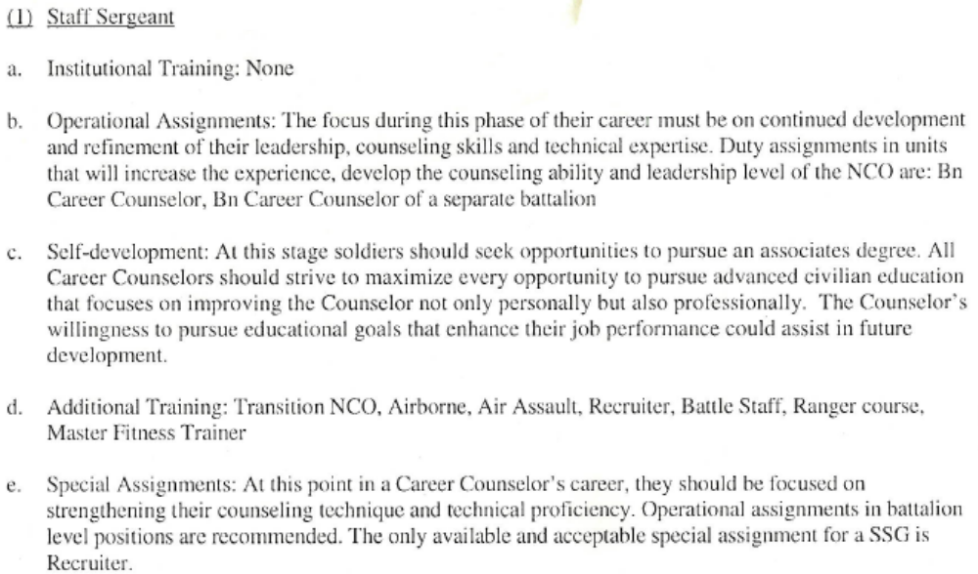
Figure H.1. SSG Professional Development
79S40:
- Performs duties shown in preceding skill level and provides technical guidance as required
- Reviews retention actions for accuracy
- Interprets regulations and provides guidance for subordinates
- Assists in the development and direction of command retention program
- Coordinates with strength managers to ensure command’s readiness posture
- Conducts staff assistance visits
- Plans and conducts retention training
- Explains unit performance data to leaders and superiors
- Evaluates subordinate's conduct of a retention interview
- Determines Soldiers' eligibility for retention duty
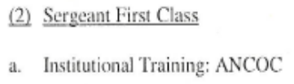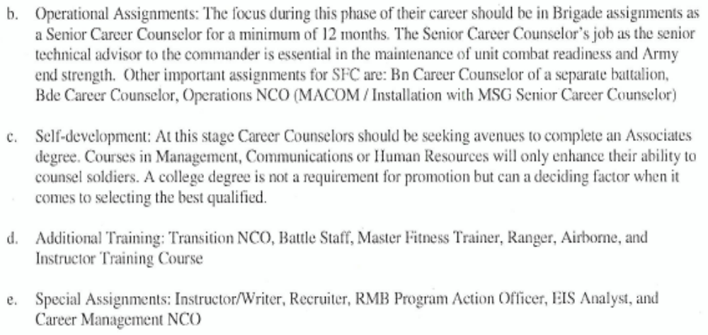
Figure H.2. SFC Professional Development
79S5O:
- Performs duties shown in preceding skill levels and provides technical guidance as required
- Analyzes retention trends; provides mentorship, training and recommends courses of action to achieve the command’s retention mission
- Serves as the Field Reclassification Authority (FRA) (applies to SR Operations positions only)

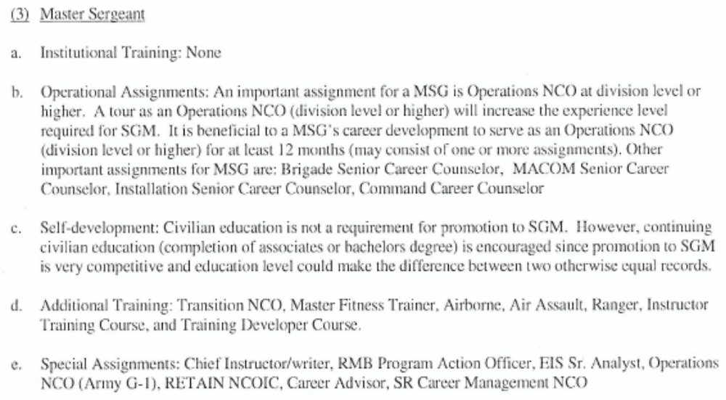
Figure H.3. MSG Professional Development

Authorizations
The ATTRS website (ATRRS Website) details standards of grade progression, minimum qualifications, and major duties for MOS 79S. Division PMOS 79S AUGTDA authorizations can be viewed at 4ID DIV REUP Collaboration Folder-79S AUGTDA Authorizations.

NCOER Guidance for Retention Personnel
The most important document that a promotion board looks at when competing at HQDA centralized promotion boards is the NCOER. It is important to note items of interest to a 79S NCOER. In regards to:
- Duty Position, a career counselor can only have a title listed in the Standards of Grade progression table, which is available at ATRRS Website.
- Daily Duties and Scopes: Daily duties and scopes are clearly defined in the major duties and specific skill level in the ATRRS website (ATRRS Website). However, when a Career Counselor is deployed, raters need to ensure that they include that in the first sentence.
- Areas of special emphasis: List the areas of special emphasis during the rating period. For example, Accomplishment of the FY09 ETS retention mission, Deployment ISO OIF 08-09, MRTT, etc.
- Additional duties: Examples are Section Sergeant; Publications NCO; Department Budget Manager; Department Hand Receipt Holder, and Special Events Coordinator.
- List three positions: List only duty positions.
- Senior Rater Bullet Comments section of the NCOER, an acronym that can help to remember what bullet areas to write about is PPPS. PPPS stands for promotion, potential, performance, and schooling.

NCOER Tips:
- If you list something on the front page of the NCOER form, such as in the area of special emphasis, you must ensure that you bullet it on the backside in the respective area of evaluation
- Justify/quantify bullet comments
- Place the strongest bullet first.

PMOS 79S Career Counselor Professional Development
A career counselor’s professional model provides leaders with information on how a career counselor’s professional development path should unfold. DA PAM 600-25 provides professional development guidance for a career counselor.
- The model can be accessed at Army Training Support Center
- The standards of grade authorizations for a career counselor can be found at ATRRS Website
- A sample brief that was provided to the FY08 SFC promotion board is available for download at 4ID DIV REUP Collaboration Folder-Promotion Board Brief. It is important to note that each board brief is unique to that year’s board and is subject to change with each board. However, the slides will provide useful information to a career counselor competing for promotion. A snapshot presentation, located in the Training Information section at HQDA Promotion Board Brief depicts the HQDA centralized promotion board process.
Appendix I
Training

Training remains the focal point to ensure Soldiers are combat ready. Retention personnel need to ensure that they conduct training with the priority on combat readiness then MOS sustainment training. As leaders, one must monitor and record training. This allows the leader to identify training weaknesses in subordinate personnel. Training should not be isolated specifically to MOS tasks but should include Warrior tasks, etc. Refer to Figures I.1 for a sample training record. An expanded version of a training record is available for download at 4ID DIV REUP Collaboration Folder-Training Tracker.

MOS Proficiency | SL4 | 805B-79S-4007 | 805B-79S-4008 | 805B-79S-4009 | 805B-79S-4010 | 805B-79S-4011 | 805B-79S-4012 | 805B-79S-4013 | 805B-79S-4014 | 805B-79S-4109 | 805B-79S-4110 | 805B-79S-4111
Legend: T-Trained P-Proficient U-Untrained |  | Process a Service Remaining Requirement | Process a Reclassification Action | Process a Retention Packet | Process a Soldier for the Bonus Extension and Retraining Program | Conduct a Retention Ceremony | Process a Request for Cancellation of Extension | Process a Request to Waive a Reenlistment Option | Process a Bar to Reenlistment | Prepare a Retention Data Worksheet (DA Form 4591-R) | Advise Commanders/Soldiers on Processing an Erroneous/Defective/Unfulfilled/Fraudulent Enlistment/Reenlistment Commitment | Manage a Retention Mission
Rank Name
Rank Name
Figure I.1. Training Record

Appendix J
Briefings

Another administrative process that retention personnel need to develop during the set up phase is a program brief. There are various types of briefs with various names. Military standard brief formats are governed in Appendix B of FM 5-0, Army Planning and Orders Production. There are four types of military briefings and you will find yourself in situations where you will have to conduct or participate in them. The more common briefings you will conduct or participate in are:
- Information
- Decision
- Staff
- Mission

When setting up your retention program, the first type of brief you need to develop is a brief commonly referred to as a “Retention In-brief.” In this type of briefing you want to convey information substantiated with facts; hence, you would follow the guidance, of FM 5-0, to conduct an information briefing. A sample brief is available for download at 4ID DIV REUP Collaboration Folder-In-Brief.

The next common type of brief you will conduct and or participate in is the staff brief, known as the “staff call.” In this type of brief, the individual in charge of the meeting uses staff estimates to determine a preferred course of action to accomplish the mission. Retention personnel need to familiarize themselves with Appendix E of FM 5-0 to understand how and what to brief during a staff brief. Frequent updates develop a “running estimate” that the commander will use to determine the best COA to accomplish the mission.

Lastly, the next type of brief you will find yourself frequently conducting is a decision brief. Your responsibilities will require an answer to a question or a decision for a particular course of action. When this occurs, you will utilize a decision briefing to obtain the answer you seek. Appendix B of FM 5-0 explains how to conduct a decision brief. For further edification, Figure A-3 of FM 5-0 illustrates how you should assemble and tab your decision staffing action.

Appendix K
Strategy

Developing a plan is essential to having steps to guide you to accomplish the mission. Without a plan, one will find they are reactive rather than proactive. Gathering information to help establish a plan is a good starting point. FM 5-0, Army Planning and Orders Production, coupled with FM 3-0, Operations, are excellent tools to help guide you when developing a plan.

Intelligence preparation of the battlefield (IPR) is essential to a commander on the battlefield. Just as intelligence is important to a commander, retention personnel too can employ the same methodology to retention planning. A successful plan includes anticipation, shaping, and influencing. It is important to note that you must get out of the foxhole, go on the offensive, and attack. Historical data details information about the past that you can use while planning for future missions. Career counselors and or retention NCOs should not solely rely on automated data; they should maintain records of reenlistment accomplishments and utilize this historical data while planning or assessing a retention program. This information in conjunction with SAV’s, sensing session information, and surveys can assist in capturing the whole picture of the retention state within a unit.

Strategy Tools
To help with development of a retention plan, use the following matrix as a guide:

Plan:
- Begin by gathering intelligence. In other words, intelligence preparation of the battlefield (IPB), which includes:
- Analyze historical data. Statistical data, surveys, etc.
- Identify strengths, weaknesses, opportunities, and obstacles.
- Identify key influencers and centers of influence (COI).
- Identify your eligible market: number of eligible’s by month, quarter, and year.
- Identify from the eligible pool the number eligible for a bonus: zone A, B, and C.
- Identify when they become eligible and not eligible for a bonus and bonus zone by month, quarter, and year.
- Identify from the eligible pool when Soldiers become eligible for options and what options.
- If deploying or pending ARFORGEN, identify the periods that Soldiers in the unit will lose movement options and when they can get them back. (See Appendix E, Figures E.2-E.8)
- Identify your “Freebie” market: PFC’s, PFC’s promoted to SPC, and Soldiers that you can reenlist during the FY that were not in the mission window.
- Plan on how to conduct counseling/interview sessions with 100% of the eligible market.
- Plan to follow up on counseling/interview sessions.
- Plan on how you will employ available assets.
- Plan a battle rhythm.
- Establish an MOE. (See Appendix G)
- Plan on how to strengthen weaknesses, seize opportunities, and overcome obstacles.
- Develop a plan to advertise your program. (See Chapter 2 and Appendix C)
- Identify critical and functional tasks.
- Draft a calendar (planning guide) to guide to focus on critical points and key tasks.
- Plan on how you will obtain documents necessary to process a Soldier for a retention or reclassification action, such as obtaining APFT cards, profiles, etc.
- Plan on how you will screen records,
- Plan on how you will prepare Soldiers in RETAIN.
- Plan to allot time to prepare a Soldier’s record in order to conduct a quality counseling session.
- Develop a method on how you will track reenlistments, extension, reclassifications, DCSS, and Bars to Reenlistment.
- Develop a method on how you will publish statistics.

Prepare:
- Screen every Soldier record and prepare them in RETAIN.
- Prepare for the counseling/interview session with the Soldier.
- Prepare for follow up counseling/interview sessions. (See Appendix B)
- Prepare how to accomplish the tasks you identified in the planning phase.
- Prepare your calendar with specific events, training, training exercises, deployment, etc.
- Prepare courses of actions on how to get to your desired end-state.
- Create, prepare, and order advertisement material. (See Appendix C)

Execute:
- Execute the plan you prepared for.

Assess:
- Assess--the planning steps, what you did during preparation, and the execution of the plan.
- Identify shortfalls in the plan.
- Make necessary changes to the plan and courses of action to focus on accomplishing the task
- Assess achievement of benchmarks/accomplishment of tasks/missions.
- Conduct AAR

Glossary

Section I – Acronyms
AC Active Component
AOPS Assistant Retention Operations NCO
AR Army Regulation
AUTH Authorized
BCCC Basic Career Counselor Course
BCT Brigade Combat Team
BDE Brigade
BN Battalion
CAR Careerist Soldier
CCC Command Career Counselor – Retention SGM
CCOY Career Counselor of the Year
CCOYB Career Counselor of the Year Board
CSM Command Sergeant Major
DRO Division Retention Office
FRG Family readiness Group
FRSA Family Readiness Support Advisor
FY Fiscal Year
GO General Order
GWOT Global War on Terrorism
IAW In Accordance With
INIT Initial Term Soldier
IPB Intelligence Preparation of the Battlefield
MOS Military Occupational Specialty
MSG Master Sergeant
NCO Non-Commissioned Officer
OH On Hand
OIF Operation Iraqi Freedom
PAO Public Affairs Office
PMOS Primary Military Occupational Specialty
RC Reserve Component
RECLASS Reclassification
REQ Required
RPI Reenlistment Publicity Item
SAV Staff Assistance Visit
SFC Sergeant First Class
SGM Sergeant Major
SOPS Senior Retention Operations NCO
SSG Staff Sergeant
TDY Temporary Duty
Section II - References
AR 600-8-8 The Total Army Sponsorship Program
AR 600-20 Army Command Policy
AR 600-35 Army Force Stabilization System
AR 600-100 Army Leadership
AR 601-2 Army Promotional Recruiting Support Programs
AR 601-280 The Army Retention Program
DA PAM 600-25 U.S. Army Noncommissioned Officer Professional Development
Guide
DA PAM 611-1 The Army Interview
DA PAM 611-21 Military Occupational Classification and Structure
FM 1-0 Human Resources Support
FM 1-01 Generating Force Support for Operations
FM 3-0 Operations
FM 5-0 Army Planning and Orders Production
FM 6-22 Army Leadership
FM 7-22.7 The Army Non-Commissioned Officer Guide
LTC 25-20 A leader’s Guide to After-Actions Reviews
TITLE 10 USC (2261) Title 10
STP 12-79S45-SM-TG Soldier’s Manual and Trainer’s Guide MOS 79S
CALL HANDBOOK, THE FIRST 100 DAYS, COMMANDER AND STAFF, NO. 08-10
CALL HANDBOOK, THE FIRST 100 DAYS, LEADER’S HANDBOOK, NO. 07-27
CALL HANDBOOK, UNIT RESET, NO. 08-33

Section III – Sample Documentation Links

4ID DIV REUP Internal Collaboration Folder-AKO
- Army Values
- Bar Review
- Battlefield Circulation Calendar Sample
- Business Card Template
- Cancellation of Extension Memorandum
- Cancellation of Reenlistment Memorandum
- Career Counselor, Badge Orders
- Career Counselor Creed
- Career Counselor of the Year Board Packet
- Career Counselor PMOS Order Documents
- Career Counselor, Reclassification Request to become
- DCSS Removal Memorandum
- Decision Paper
- Defective /Unfulfilled Documents
- Deployment Equipment Checklist
- Evaluation Observation Form
- Executive Summary (EXSUM)
- GCMCA Bar Memorandum
- Hip-Pocket Scholarship, Commanding General
- In-Brief
- Information Paper Sample
- Leaders Book
- Letter of Concern
- Manning
- MDMP Worksheet
- Media Talking Points
- Mission Target-MOE Calculator
- NCO Creed
- Oath of Reenlistment
- One-Pager Report
- Policy, Incentive/Awards
- Position paper
- Promotion Board Brief, HQDA/CMF
- RC2AC Documents
- RCP Exception Example
- Reclassification Examples
  - Mandatory
  - Medical
  - Voluntary
- Recurring Report
- Redux Documents
- Soldier Request-NCO Response
- Staffing Action Example
- Staff Assistance Visit Memorandum
- Staff Study Sample
- Start/Stop SDAP
- Survey Exit/Reenlistment
- Tracker, Training Matrix
- Training Memorandum
- USR, Retention Sample
- Warrior Ethos
- Way Ahead Snapshot
- Welcome Letter
4ID DIV REUP Collaboration Folder-79S AUGTDA Authorizations
Recruiting and Retention School MOS 79S Proponent-STP
Recruiting and Retention School MOS 79S Proponent-Forms


